Parallel and distributed systems

Quiz 1

Mir Hussain

**Q1.** Briefly demonstrate and write down how to filter a specific open Flow packets in Wireshark.

**Ans.**

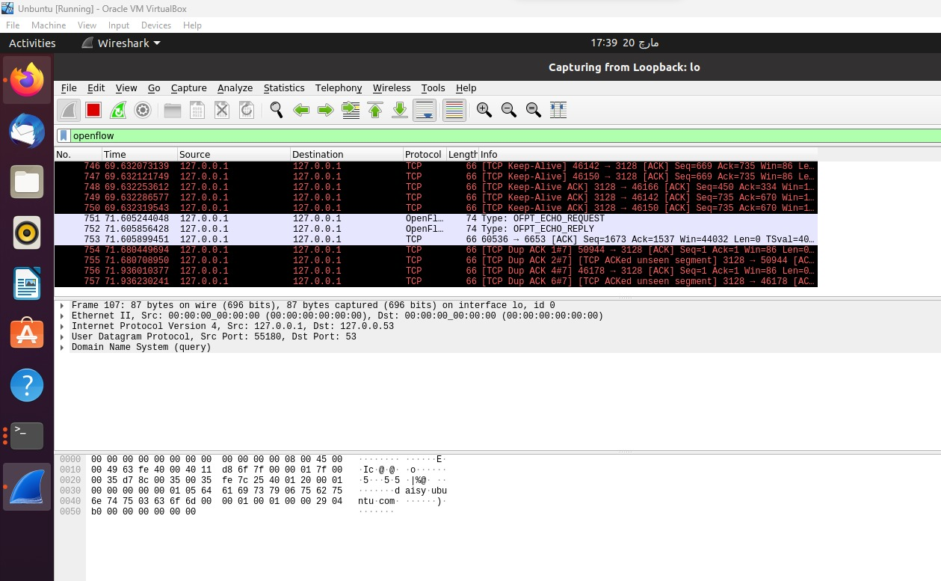

**Q2.** Write down the command of starting a minimal OpenFlow topology (2 hosts, 1 switch and 1 controller) with mininet

**Ans.**

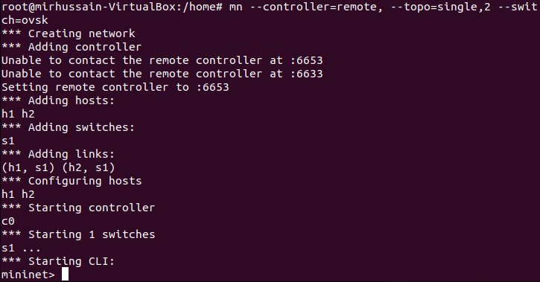

**Q3.** Explain the information shown when you use "dump" command for the minimal OpenFlow topology in Q2.

**Ans.**

**Q4.** By using which command in mininet can you test the connectivity between hosts. Give an example**.**

**Ans.**

